ASE LAB ASSIGNMENT 7

Lab ID: 6_2

Name: Madhuri Sarda

Student ID: 16291679

Class ID: 21

Partner Name: Udaya Byreddy

Student ID: 16293204

Class ID: 3

Customer details html page

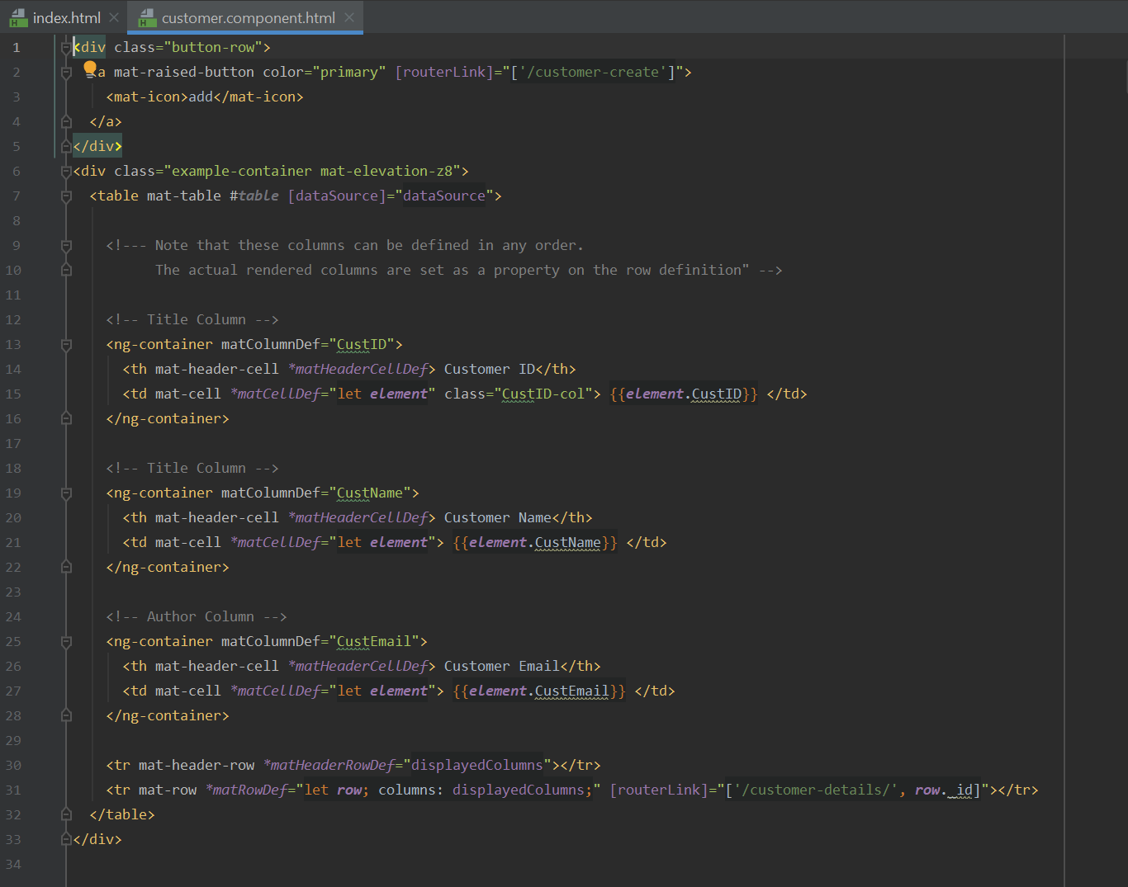

Customer details .ts page

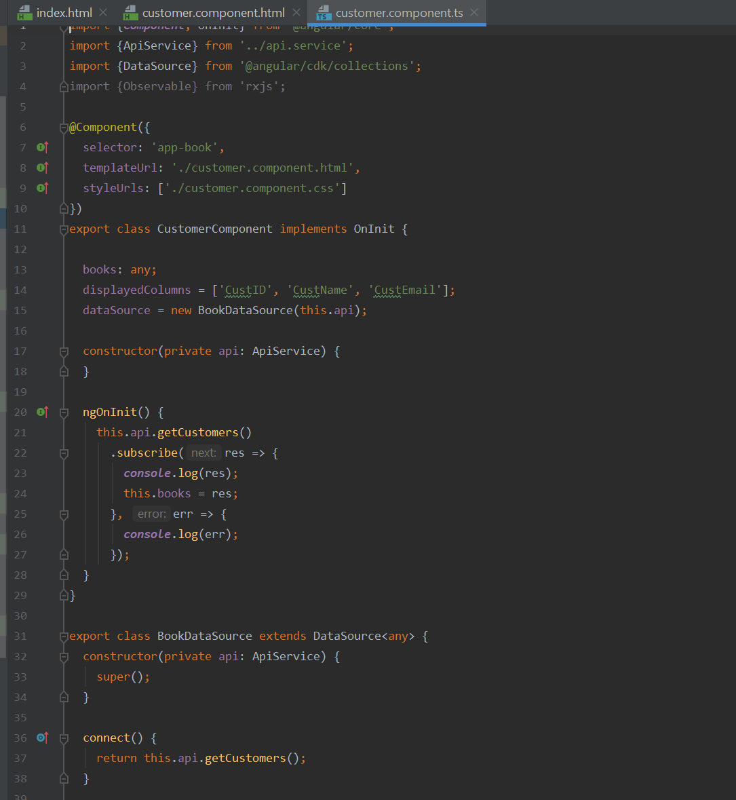

Create component html page

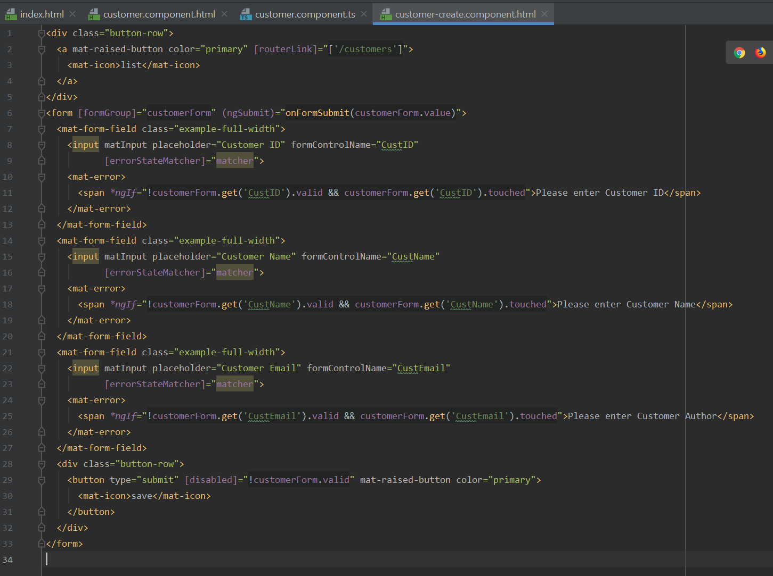

Customer create component .ts page

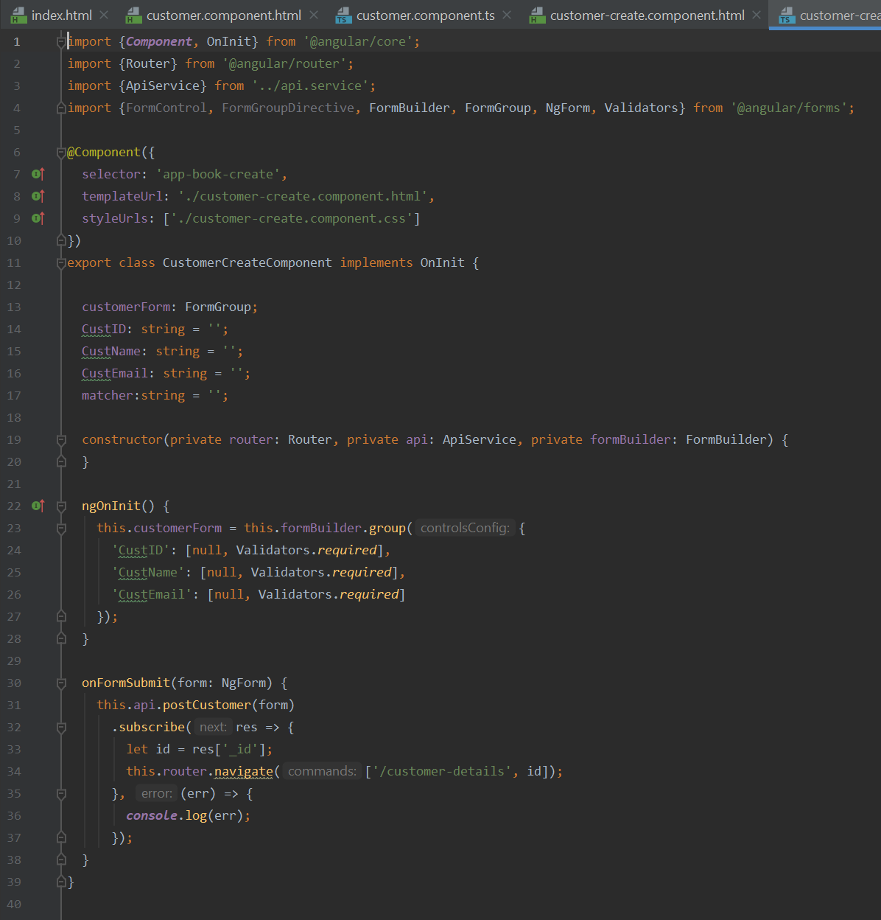

Customer view details html page

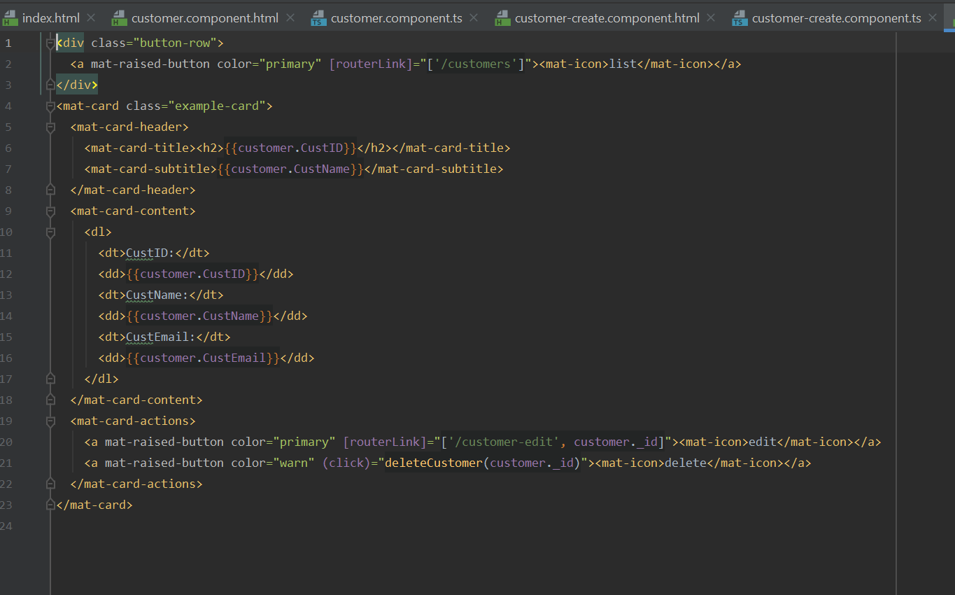

Customer view details .ts page

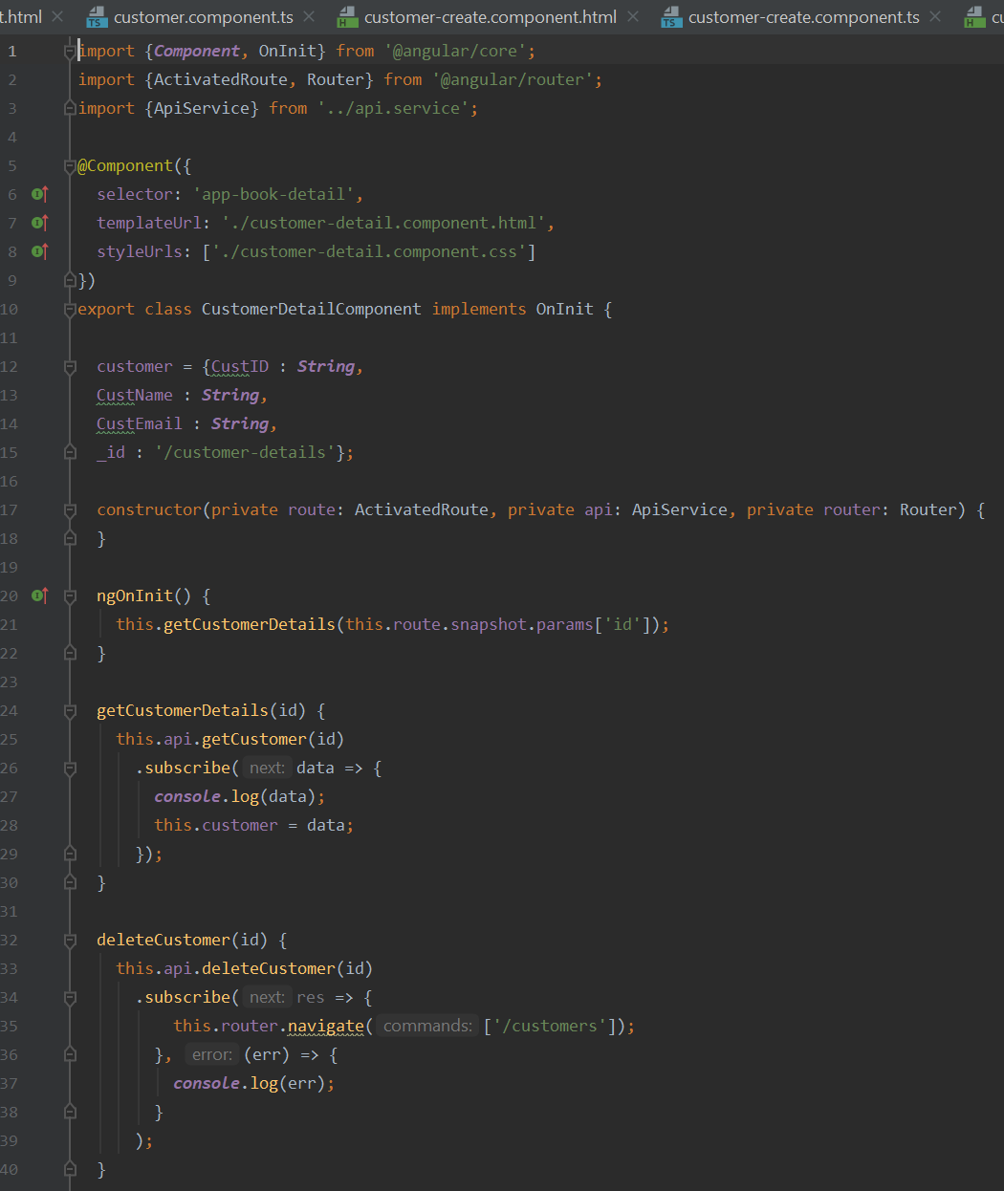

Customer details edit html page

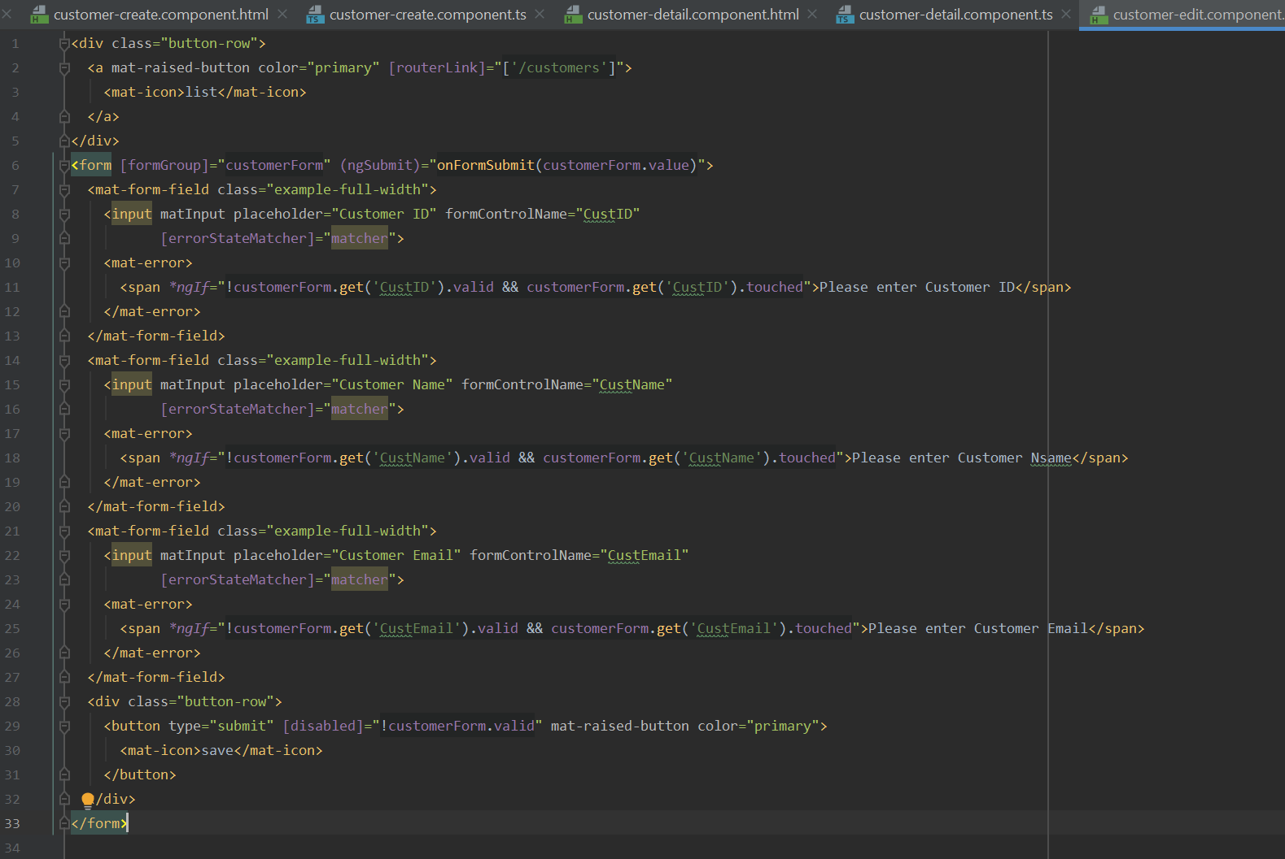

Customer details edit .ts page

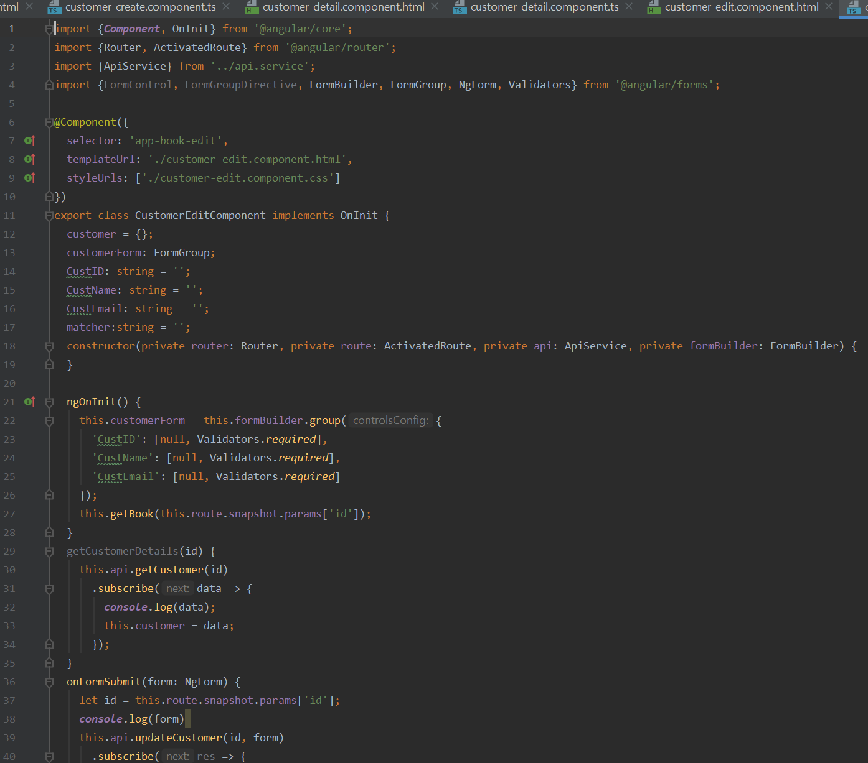

App components details .ts page

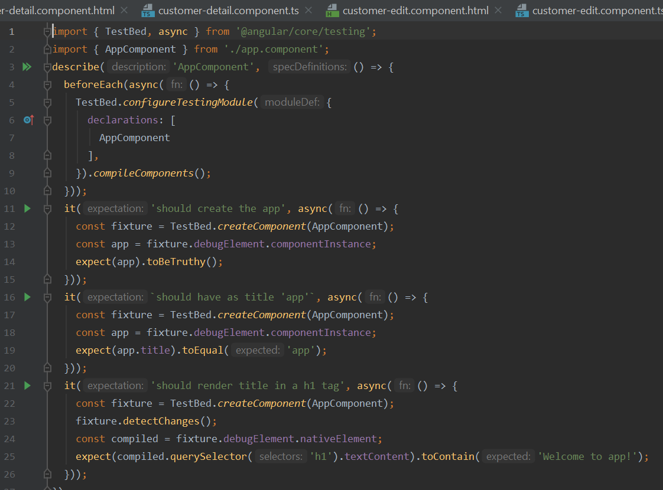

App module .ts code

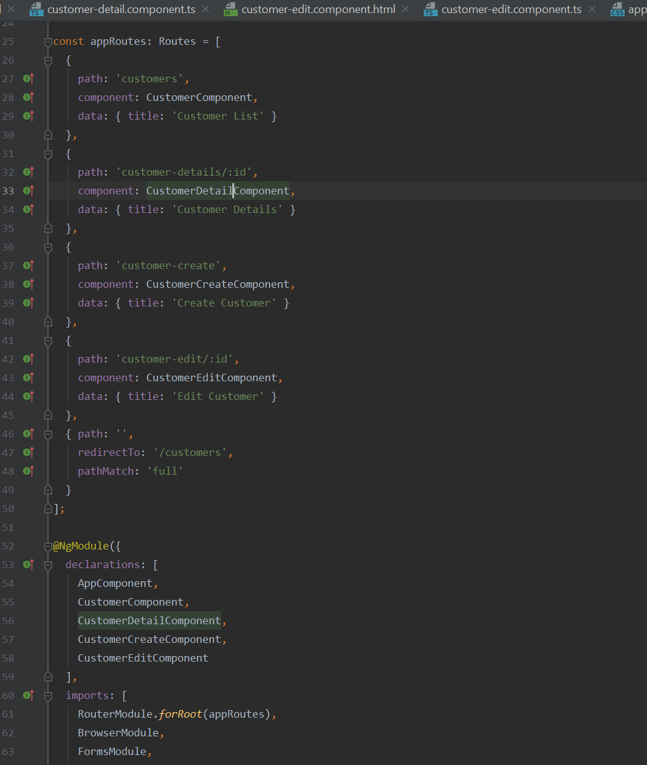

Mongo DB User Credentials

